**FetchApp**



**Design Documentation**

Virgilio Garcia

Anthony Martinez

Juan Patulandong

Jonathan Tan

Brian Taube

**Table of Contents**

Introduction 1

Project Requirements & Assessment 1

Background 2

Software Development Process Model 2

Technology Stack 3

iOS 4

Heroku 4

MongoDB 4

Parse 5

Swift 2 5

Cocoa Touch 6

SWRevealViewController 6

Description 7

Features (List) 7

User Registration 8

Custom account profile 9

Request a Ride 10

Interactive Map 11

Mile Tracker 12

Friend List 13

Friend Groups 14

Business Groups 15

Rankings 16

Silent Mode 16

Task Page 17

**Introduction**

FetchApp is a ridesharing app designed for iOS that integrates utility with social media. Built upon then proven technologies such as Parse Server and Apple’s MapKit and Core Location framework, FetchApp makes ridesharing fun and competitive. FetchApp is designed using the Xcode IDE and written in the Swift programming language. Xcode was chosen for its visual development aspects which provide the benefit of rapid development.

**Project Requirements & Assessment**

Mid-quarter goals –

1. Login & registration
2. User location tracking
3. Mile counter
4. Function to send job alerts to users

Final goals –

1. Friend’s list
2. Friend groups
3. Business groups
4. Local rankings
5. Simple and clean user interface

We managed to integrate all of the above features into our application plus all of the following below.

* Custom editable user profiles including profile pictures, all stored within the database
* Map tracing to show user’s movement while travelling
* Interactive map for location selection which allows users to pan the map for their desired location or use a search bar to manually input the address and search for it
* Driver’s task page links to Apple Maps to provide quick and easy navigation
* Experience system that dynamically calculates a user’s level based on experience points (miles driven)
* Silent mode – This mode is integrated within the application however currently it simply sets the user’s status from green to grey in the database. If our application had push notifications, before push notifications are sent out the application would check user status’ in the database. Users who have a grey status would not receive any notifications. However, because an Apple Developer Account is required to implement push notifications, push notifications are not implemented within the application and thus it simply sets the status of the user at the moment.
* Status indicators – Indicates when a user is searching for a ride (red), idle (green), or unavailable (grey)
* Several validation methods are included within all of our features which predict possible user errors in order to minimize failure rate and maintain efficiency

**Background**

**Software Development Process Model – Waterfall Life Cycle**

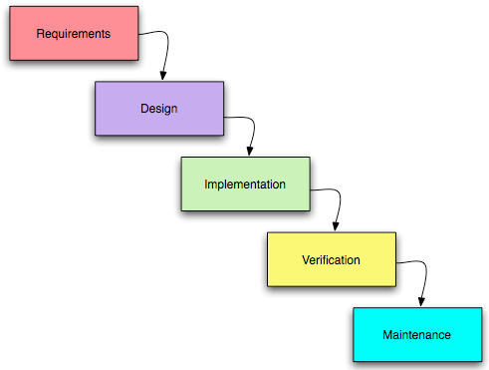

While developing our application, we followed the simple waterfall life cycle. In the beginning weeks of the quarter, we thought up the requirements and drafted the initial design. From there we split into groups to work on different parts of the project. Virgilio and Juan focused on the mile tracking portion of the application, Anthony and Brian developed the friend’s list and group portion, and Jonathan developed the user interface. We met once or twice a week, depending on our individual group’s weekly progress, to discuss what parts each group needed to incorporate into their work in order to smoothly combine all our parts at the end of the quarter. We also kept in constant contact through a GroupMe group chat. Towards the final weeks of the project, Jonathan combined all the parts together. Once we had a finished prototype, we spent the next week debugging the application, testing it on our phones, and performing maintenance.

**Download the entire finished project @** <https://github.com/jtan021/CS180-FetchApp>

**Application Installation:**

We, as a group, did not buy an Apple Developer Account so the application cannot be found in the AppStore. In order to install the application onto your iPhone follow these steps.

1. Download the entire Xcode project at the GitHub link given above
2. Open the Xcode project on an Apple computer
3. Connect the target iPhone to the Apple Computer
4. On the target iPhone, an alert should pop-up asking to “Trust” the computer, select “Trust”
   1. If you accidentally select “Don’t Trust”, simply unplug the iPhone and re-plug it back in and the alert should pop-up again
5. Now simply select the target iPhone as the target device in Xcode and select run

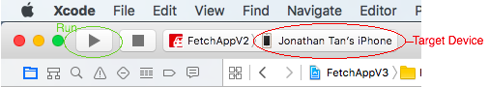

**Technology Stack**

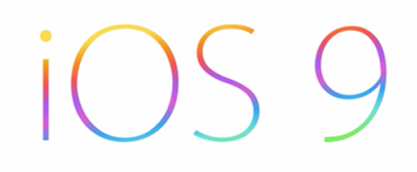

**Operating System: iOS 9**

Although there are many companies in the world that can provide similarly capable platforms to Apple, the atmosphere that Apple creates about its products are one of a kind. Apple’s iOS is one of the most, if not the most, simplistic and easy-to-use of all smart phone interfaces and is the foundation of the iPhone, iPad, and iPod touch. It is because of its simple and elegant nature as well as its strong user/fan base that we decided that Apple’s operating system would be the best fit for our application.



**Web Server: Heroku**

Heroku is a platform as a service (PaaS) that enables developers to build and run applications entirely in the cloud. Heroku abstracts much of the infrastructure of server hosting and allows developers to shift their focus straight to application development. The web server is free and handles everything critical for production – configuration, orchestration, load balancing, etc – has great scalability, and many pre-integrated services such as MongoDB. Heroku also offers application metrics allowing developers to continuously monitor throughput, response times, memory, CPU load, and errors. It is because of all these reasons that we decided to host our server using Heroku as the back-end.



**Database: MongoDB**

MongoDB is an open-source document database and the leading NoSQL database. We used MongoDB because we chose to use the open-source Parse SDK in the development of our application and MongoDB is a required component of Parse.



**Software Development Kit: Open-source Parse Server**

Parse server is a widely used mobile-backend server hosted by Facebook which contains native SDKs for Android, iOS, JavaScript, Unity, and many other platforms. Unfortunately, earlier last year the developers of Parse announced that they would be retiring their services as of January 2017. However, in response to this shift they also decided to release an open-source Parse server which allows developers to run most of the Parse API from their own Node.js server (such as Heroku). Due to its widespread-use, Parse holds an extensive amount of documentation on how to implement all of its features and also is well known for adding a powerful core, push notifications, and analytics to applications. These reasons made the open-source Parse server ideal for our application development as it is equally powerful to many of its competitors yet more simple to use and easy to learn. Not including its documentation, there are several tutorials on how to integrate the Parse server into a mobile application all over the internet.

Parse’s iOS Documentation is found here: <https://parse.com/docs/ios/guide>

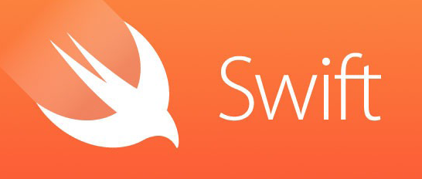

**Programming Language: Swift 2**

“A modern programming language that is safe, fast, and interactive” – Apple.

When developing an application for iOS there are only two languages to choose from: Swift 2 and Objective-C. However, with some research into the two languages it is clear that Apple’s focus in the next coming years will be to further promote and develop Swift 2 while slowly, but surely, steering away from Objective-C. Reason being that Swift 2 combines and improves all of the Cocoa frameworks and Objective-C capabilities, giving it new syntax and making it more “expressive.” Swift code also has the ability to co-exist with Objective-C files in the same project and has full access to Objective-C API. Due to these reasons, we chose Swift over Objective-C for our main programming language.



**UIKit**

The UIKit provides the necessary infrastructure needed to construct and manage iOS applications. It provides the window and view architecture needed to manage an application’s user interface, the event handling infrastructure needed to respond to user input, and the application model needed to drive the main run loop and interact with the system.

**Core Location**

The Core Location framework allows the application to determine the user’s current location and heading associated with the device. The application uses the CLLocation, and CLLocationManager, and CLGeocoder class of the framework. The CLLocationManager configures the location and heading data and the CLLocation object represents the generated data. The CLGeocoder class is used for converting addresses to location coordinates. This framework along with the Map Kit put together the location and map services of the application.

**MapKit**

The Map Kit framework provides an interface for embedding maps directly into the views of the application. It also provides support for adding overlays such as polylines and performing reverse geo-coding lookups to determine addresses given location coordinates. This framework along with the Core Location framework put together the location and map services of the application.

**MessageUI**

The MessageUI is the framework responsible for allowing the application to send text messages directly to users’ Fetch Account phone number. We utilize this method to notify users instead of using push notifications because push notifications require an Apple Developer Account.



**Third Party: SWRevealViewController**

The SWRevealViewController is a UIViewController subclass used for revealing a rear view controller behind a front controller. We implemented the navigation menu of the application using this third party subclass designed by John Lluch. The code for this subclass can be found on GitHub at <https://github.com/John-Lluch/SWRevealViewController>.

**Description**

FetchApp is easy to use and easy to set up. Once you’ve registered an account, which can be done directly from the application right after installation, you can start adding friends, requesting rides, and/or making pick ups. If you need a ride it’s as easy as typing in your location and destination, FetchApp will even search the map and help to fill in the addresses for you. If you are unsure of the exact address, FetchApp also allows you to pan the map and input the target location by centering a pin. Once you have updated your status to request a ride, your friends will let you know if they’re available to make your trip. After selecting a driver, to ensure that only one car arrives for you, you’re off to your destination! The application then tracks your movement, drawing a polyline on a map as you move, and calculates the distance you travelled. Once you have reached your target destination, the calculated distance is added to your driver’s account as experience points. The experience points define the user’s level so the more you drive your friends around, the higher your level! Thus making driving your friends both fun and competitive.

**Features**

* User Registration
* Custom Account Profiles
* Request a Ride
  + Interactive Map
* Mileage Tracker
* Friend List
* Friend Groups
* Business Groups
* Rankings
* Silent Mode

**User Registration**

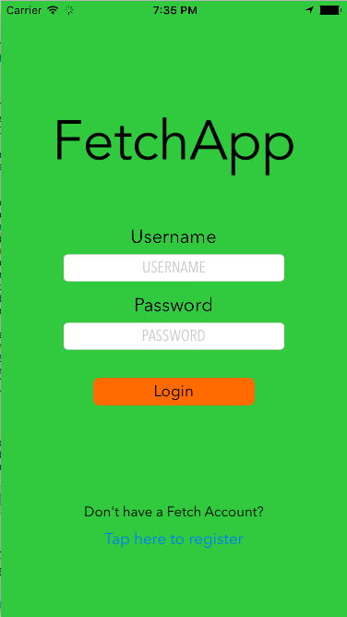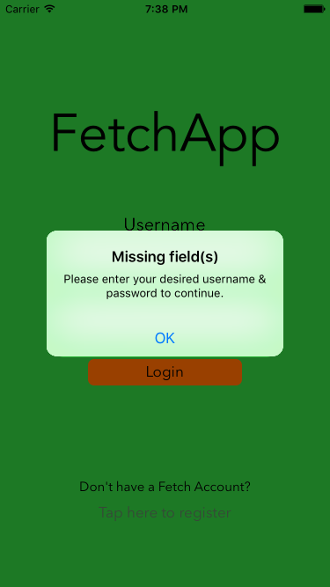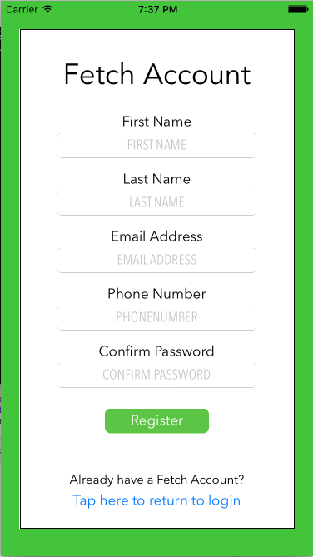

User accounts are registered from within the application. Desired username and password for new Fetch Account users are defined at the starting login view. From there new Fetch Account users select the registration button and input the required information.

User accounts are case-sensitive and the login and registration procedure check for the following cases when authenticating users:

Login validation:

1. Username and password field are filled out
2. Valid username and password entered

Registration validation:

1. Username and password field are filled out
2. Username contains alphanumeric characters only and is available
3. All registration fields are filled out
4. Email address is not taken
5. Phone number contains 10 digits
6. Confirmed password is identical to original password entered at the login view

Once you select to register in the registration view, you receive an alert view describing either your successful registration or an error. Upon successful registration, you can login from the login view.

**Custom Account Profile**

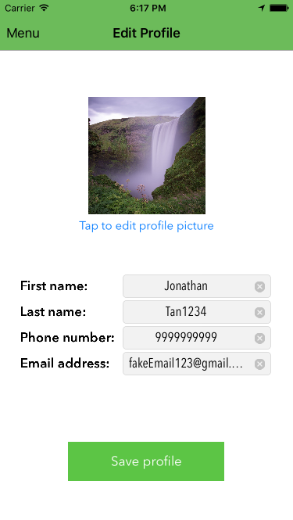 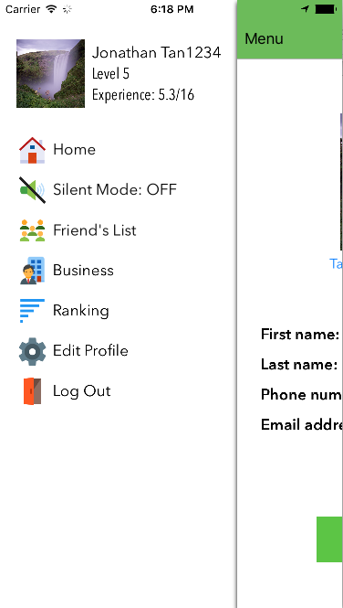



FetchApp allows for custom user account profiles in which the user can edit their profile picture, name, phone number, and email address in the “Edit Profile” view and save the new information straight to the database by tapping the “Save profile” button. Users select their profile picture from their iPhone’s Photo Library and once they save the profile, the photo is uploaded as a PFFile to the Parse database. The user’s custom account profile is what shows in the navigation menu and on the user’s friends’ friend lists.

**Request a Ride**

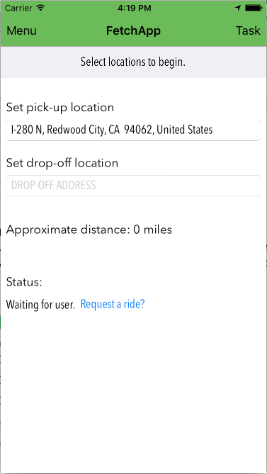

Ride requests are made from the main view. From there, the user taps on the pick-up and drop-off location text fields which redirects the user to the map search view for selecting an address. The pick-up location to start is automatically set to the user’s current location. The only time it may not be set to the user’s current location to start, is when the application is first opened as it may lag and must first ask the user to use the phone’s location services.

**Interactive Map**

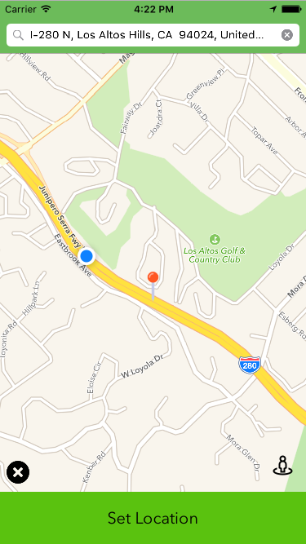 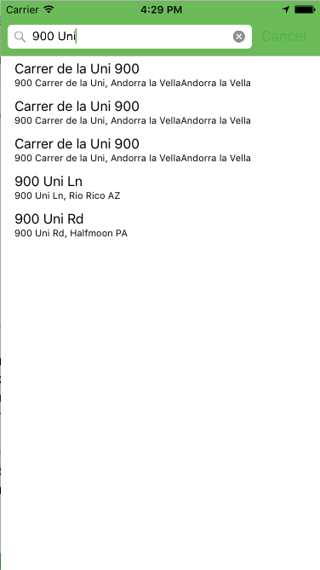

In the map search view, the application has an interactive map where the user can select an address by either searching for an address by manual input or by panning the map and selecting the location using the pin. The pin is on top of the map view at all times and designates the target location as it is the center point of the map view. If the user enters the destination into the search bar, the search bar assists the user by auto-filling the results against Apple Map’s known locations. Once the user selects the address from the search bar, the map view centers in on the target location. If the user decides to pan the map, the application reverse geo-codes the coordinates of the pin to obtain the address and automatically sets the search bar with the pin’s address. In the bottom corners of the map search view, there are two buttons. The cancel button on the left is to cancel the action and return to the main view. The button on the right which resembles a person is to reset the map view to center in on the user’s current location. Once the user decides on the location, they simply click the “Set location” button to return to the main view. The main view will now display the new location in the pick-up or drop-off address text field, depending on which one was chosen to be edited.

**Track Mileage**

 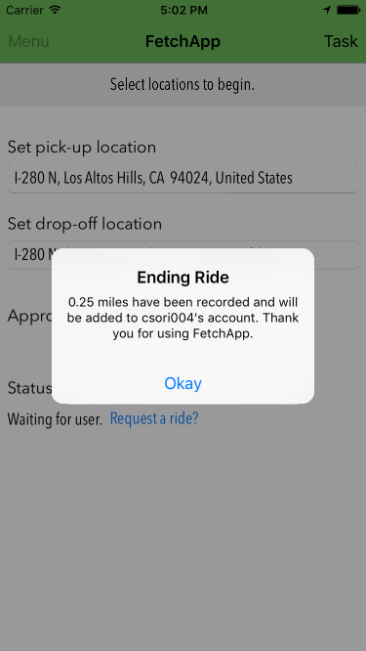

FetchApp generates a polyline to trace the user’s movement within an map view and automatically tracks the distance travelled when a user is using the ride-share function of the application. The distance travelled label automatically updates as the user moves and once the user arrives at their target destination, they simply click the “I have arrived at my destination” button and the distance travelled is recorded and saved to the driver’s account as experience points.

**Friend’s List**

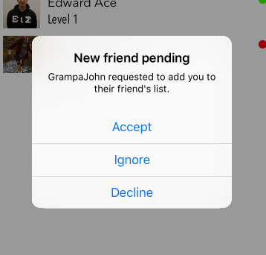FetchApp provides an easy to use screen for keeping track of your friends. You simply select the “Add” button in the top right corner, enter your friend’s Fetch Account username, and wait for them to accept your friend request. If a user has a new friend request, the “New friend request(s). Tap to view” button appears at the bottom of the Friend’s List screen. The user taps that button and accepts, declines, or ignores friend requests.

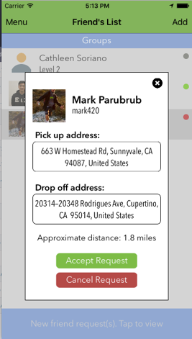

From the Friend’s List view, the user can see the status of their friends, check if any of their friends have ride requests, and choose to whether or not to accept ride requests.   
  
Status indicators – Green: Available

– Red: Requesting a ride

– Grey: Unavailable

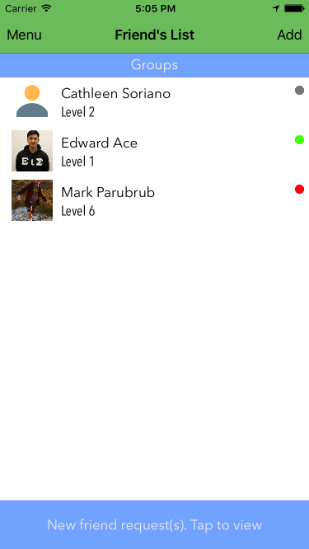

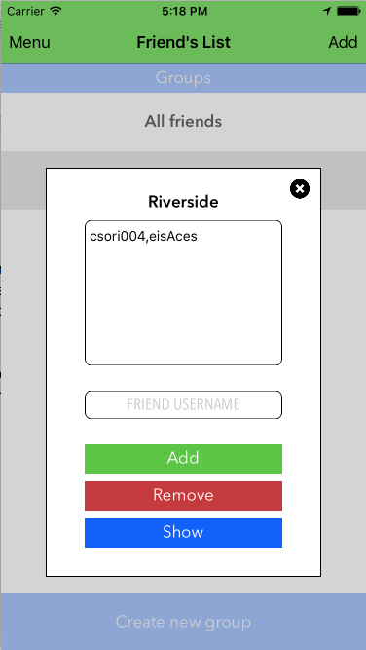**Friend Groups**

****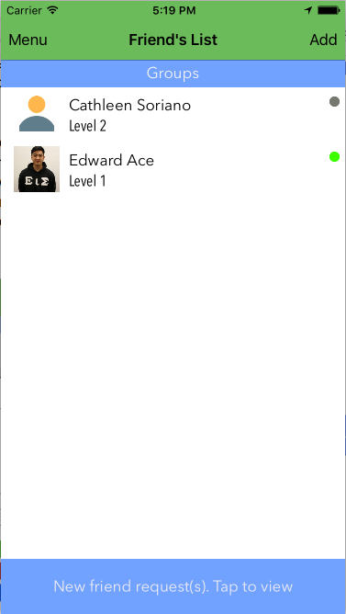

Pictures from left to right: Displays group view in friend’s list view; displays the view which pops-up when a group is selected; displays the new friend’s list when “Show” is clicked on a group pop-up view.

Group categories can be created within the application to help the user organize their friends. Separate your friends by city, school, clique, or whatever else you want!

All groups are unique per user, meaning the user can not have two groups named the same name. All group members must also currently be friends with the user so if the user tries to add someone who is not currently on their friend’s list, an alert view will pop-up displaying an error. When a user selects a group, they can see the current users within the group by username and choose to add new friends to the group, remove friends from the group, or show the current group in the Friend’s List view. If a user selects “All friends,” the Friend’s List simply refreshes to show all the user’s friends again.

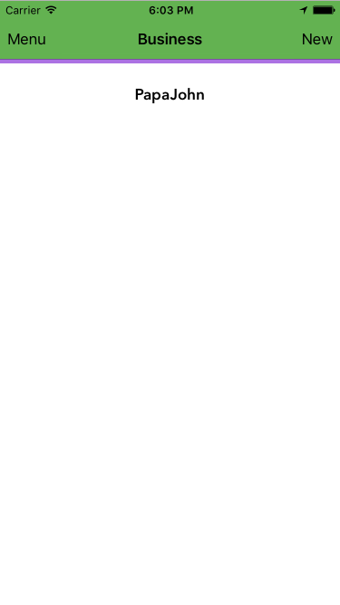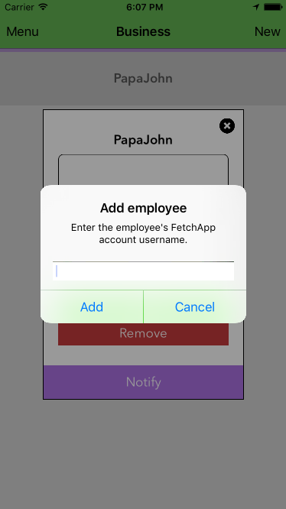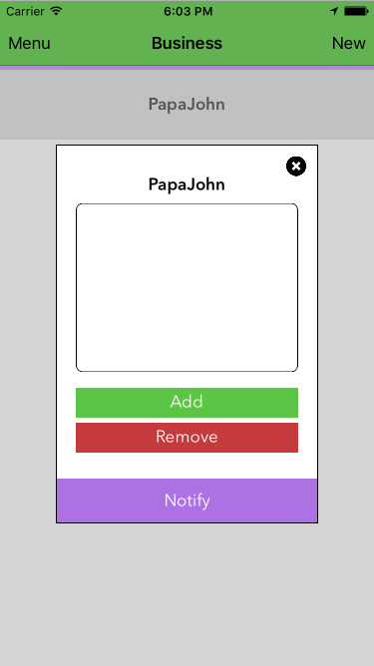**Business Groups**

Business groups are also available in FetchApp. Business groups operate similarly to regular groups except that it contains a “Notify” button which notifies all employees within the groups that the business group owner has a job. The Business group checks for the same things as groups.

Friend Group & Business Group Validations:

1. Check that the input field is not empty
2. Check that the input Fetch account username is on or not already on the list (Depending if the user is trying to add a user or remove one)
3. Check that the input Fetch account username is in the user’s friendlist
4. If all fields pass, add/remove the user to/from the group

**Rankings**



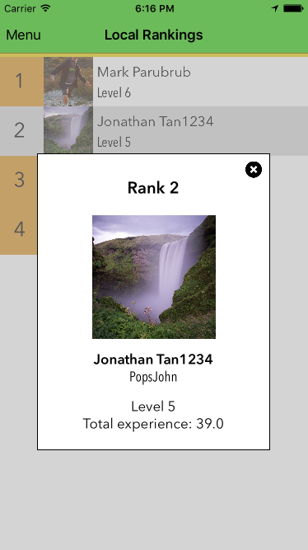As you drive your friends your mileage will be recorded as experience points. Gain enough experience and you can level up. With rankings you can see which of your friends are being the most active driving participants on FetchApp.

**Silent Mode**

Silent Mode is a setting that can be accessed directly from the main menu.

With silent mode on you can still view what’s going on in FetchApp but let your friends know that you’re not currently available to help with rides.

Currently, silent mode simply sets the user’s status in the database to “grey” which indicates that the user is not available. If our application had push notifications, we would check the user’s status before notifying the user that their friends need rides. If the user’s status was green, they would obtain the push notification. If the user’s status was red or grey, they would not because red means the user is currently requesting a ride and grey means that they are unavailable.

**Task View**

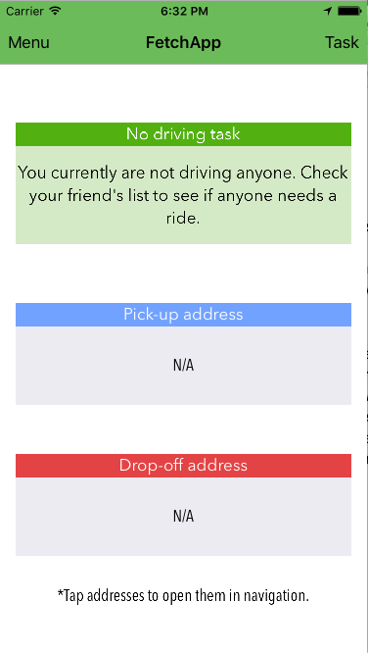

The task view page is accessable from the main view of the application. If the current user is a driver, their task view page looks like the picture on the right. If the current user is not a driver, their task view page looks like the picture on the left. If the user is currently set as a driver, the application blocks the user from requesting rides until they have finished their task. The task view is also linked to Apple Maps in the sense that if a user taps on the listed address, and the address is not “N/A”, the application automatically opens Apple Maps and sets up the navigation for the user.